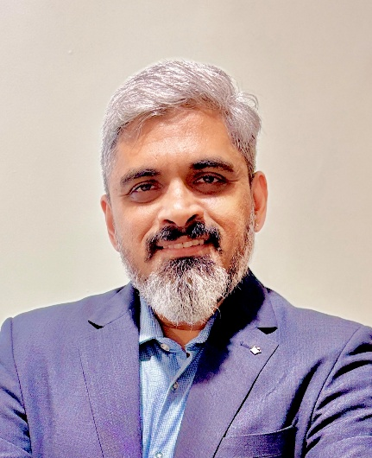
One request. Your submission in format below will help avoid edits or revisions. More so your description in your own words will be more authentic. Please stay within the number of words in this example. This information is required at many places in the back end & front end. Also send one recent photo in JPG/ JPeG like the LinkedIn one & one video of 2-3 minutes about you talking about your expertise.
1. Description:
Multi-dimensional Business Leader driving Operational Excellence and Smart Manufacturing.
2. Short description:
Multi-dimensional Business Leader with 30 yrs of expertise in the manufacturing industry driving Operational Excellence and Quality in Railway and Automotive sectors; and Startup Founder with entrepreneurial initiatives championing Smart Manufacturing, building eMobility and creating Circular Economy business.
3. Full Description:
Multi-dimensional Business Leader with a track record of delivering operational excellence and exceptional business results with experience spanning 30yrs in the Manufacturing Industry with leading global organizations across Railways, Automotive and Engineering sectors. He has grown organizations from ‘start-up’ to ‘scale-up’ in multi-projects and global programs, and led multi-dimensional teams and supply chains.
As a startup founder and management professional, he is a strategic leader instrumental in developing the big-picture vision and driving the dynamic mission with special focus on Operational Excellence through Smart Manufacturing, Quality Management and people-process & systems.

4. Professional Summary
Highlights:
Babu is a multi-dimensional Business Leader with an experience spanning 30yrs in the Manufacturing Industry. He has held senior management positions with leading global organizations across Railways, Automotive and Engineering sectors, and led multi-projects and global programs with multi-dimensional teams and supply chains. He has a track record of delivering operational excellence and exceptional business results and fostering ‘start-up’ to ‘scale-up’ growth.

- In his entrepreneurial avatar, as well as corporate career, he is a strategic leader instrumental in developing the big-picture vision and driving the dynamic mission with special focus on Operational Excellence through Smart Manufacturing, Quality Management and people-process & systems.

- He is the cofounder and COO of startup Sooorya EV which is building electric vehicles for shared eMobility.
- He is cofounder of ReUpyog, a circular economy business; presently transitioning to strategic advisory role.
- Babu as the Chief Business Development Officer – India at 5G/ Fifth Gen Tech, champions Smart Manufacturing solutions and Industry 4.0 to the manufacturing industry.
- In his corporate career at Alstom, in the Railways sector – he has led Operations and Quality to develop the Rolling Stock Manufacturing plants, and has also led the Supplier Management operations, which developed the Indian supply base for quality & capacity – achieving operational excellence and right first time success for multi-project programs delivering Metro Trains with high Quality, Performance & Customer satisfaction for several Indian and Global projects.

- At Daimler, he was instrumental in setting up the sourcing road map, and thereafter handled Quality leadership roles, where led and setup up the Quality Assurance for the greenfield Truck plant and successful launch of Medium-duty and Heavy-duty Trucks to Indian and Global markets under the BharatBenz, Mercedes and Mitsubishi FUSO brands. He pioneered the Bus project to set up the plant, product and processes for Buses and headed the Quality Management leading to successful launches of Fully-build Buses for domestic and export markets.

5. Key Achievements
Babu is an accomplished Business Leader who leads by example and lifts up the team to exemplary standards and high achievements.

As the Cofounder and COO of startup Sooorya EV – he leads the engg and manufacturing aspects for creation of the purpose built electric vehicle platform.
At ReUpyog, Babu was instrumental in creating the innovating circular business process and solutions for the avoiding EWaste and adopting renew - repair – reuse, and has created 1000s of circularity transactions.
Babu, as Chief Business Development Officer – India for 5G/ Fifth Gen Tech, he has championed Smart Manufacturing solutions and Industry 4.0 to several major and small & medium enterprises – creating a healthy business pipeline and delivering operational excellence and resulting in cost savings/ efficiency benefits to the tune of 20%-30% or more from the baseline.
In his corporate career at Alstom, in the Railways sector – He has driven turnaround in Rolling Stock Manufacturing, Quality and Supply chain transformation across several major RollingStock projects like Metros Chennai, Kochi, Lucknow, Sydney, Montreal, Mumbai, Perth (from Alstom SriCity, and Agra-Kanpur, Delhi RRTS (by takeover of Bombardier site, Vadodra) ; electric Locomotive WAG12B (from Madhepura); besides supplier managemnet Signalling and Infra Project. He also headed the Supplier Management operations, he developed the Indian supply base and ramped up the quality & capacity.
- Multi-Project rolling stock manufacturing from startup to serial deliveries of 75 Trains in 2 years
- High customer satisfaction with Right First time and 100% OTIF and zero part shortages
- Operational excellence and 3-fold reduction in quality cost, and efficiency improvement by RFT and Quality loop program, with smart manufacturing and digitalization
- Supply base rampup and capacity increase 3X with 50+ key suppliers serialized for multi-project programs and exports
- Right first time 100% product development go on time with OTIF 100%
- Significant serial quality reduction – down by 50% and PPM levels below 1000 at sites.
At Daimler, he was instrumental in startup and scale up for the Truck project and thence the Bus project, which he pioneered. He provided Quality leadership resulting in -
- setting up and achieving the sourcing roadmap for 90% localization in 12 months.
- setup and led the Quality Assurance (Vehicle) for Truck, and Quality Management for Buses India.
- successful launch of Medium-duty and Heavy-duty Trucks
- successful launches of fully body-built Buses for school, staff transport and super-high deck luxury MB coach for intercity.
- achieved market share and growth in Indian and Global markets under the BharatBenz, Mercedes and Mitsubishi FUSO brands.
- setting the highest quality standards (better than benchmark of mature European plants) with field quality & reliability.
6. Areas of Specialization
Babu has expertise and leadership capabilities that support organizations in:
- Business Strategy and Program management expertise
- Leading start-up to scale up of Organizations and Manufacturing Product-programs;
- Operational Excellence and Quality
- Leadership and organization synergy with multi-dimensional Team development.

7. Education & Qualifications
Babu is a qualified engg and management professional, who continues to learn and hone by practise.
- He holds a B.Tech degree in Mechanical Engineering from NIT Calicut; and a PGDM from Loyola Institute of Business Administration, Chennai.
- He holds several qualifications: Design Thinking (MIT-Sloan & Emeritus), Corporate Quality-Ford, Lean and SixSigma BB, Digital Transformation (BCG and Univ of Virginia) and Smart Cities (EFPL)

